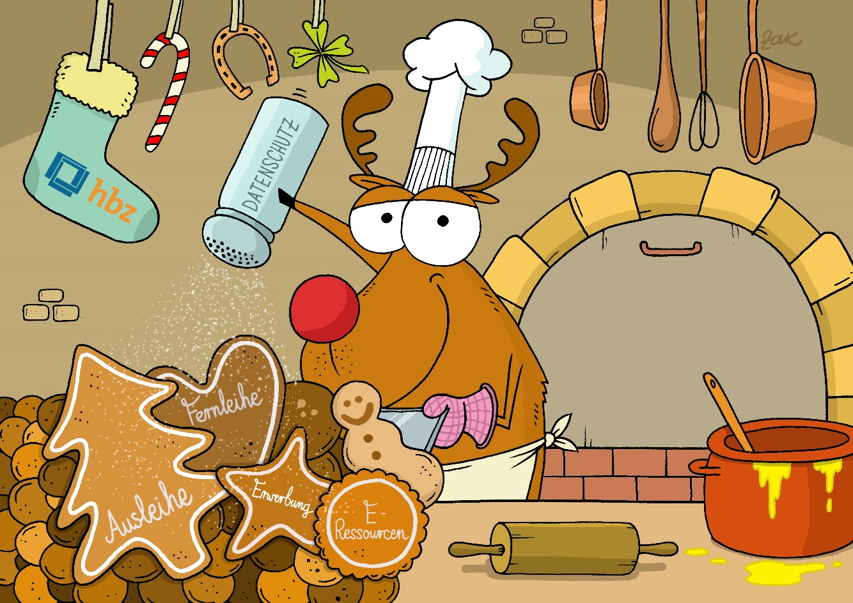
Motiv: Martin Zak

Merry Christmas
and a Happy New Year
from the Hochschulbibliothekszentrum!

The hbz wishes you, your co-workers and your family
health, good luck and success
for the coming year.

